No Magic!!!!

Here is a suggested entry technique into your trade, have a nice time doing it. This is mainly designed for 1H chart but can be traded on other time frames like 1M chart. Let us start

Open your 1H chart and apply the following indicators:
- BB with setting of 20, 0, and 2 this is used for orientation.
- SweetSpots GOLD with setting of 1000,1000,Blue,0,true,100,Blue,2

Long (buy) trades
First identify the 2 setup candles speaking from left to right or from past to recent.
The 1st candle should be bear candle and the 2nd candle should be bull candle.
1st candle lower wick is touching or crossing lines formed by SweetSpots GOLD indicator (10 pip grid lines) while the 2nd candle upper wick is not touching or crossing the 10 pip grid lines or this candle is having no upper wick at all. I call this condition as Yes/No.
That condition can work the other way around that is to say; the 1st candle lower wick is not touching or crossing the 10 pip grid lines or this candle is having no lower wick at all, while the 2nd candle upper wick is touching or crossing those lines. It is called No/Yes condition.
That is it buy at the high of the 2nd candle.
Stop is at the low of the 2 setup candles or at the low of price formed before reaching the high of the 2nd candle.
Take profit at least at 2X times your risk.

Short (sell) trades

The 1st candle should be bull candle and the 2nd candle should be bear candle.
1st candle upper wick is touching or crossing lines formed by SweetSpots GOLD indicator (10 pip grid lines) while the 2nd candle lower wick is not touching or crossing the 10 pip grid lines or this candle is having no lower wick at all. I call this condition as Yes/No.
That condition can work the other way around that is to say; the 1st candle upper wick is not touching or crossing the 10 pip grid lines or this candle is having no upper wick at all, while the 2nd candle lower wick is touching or crossing those lines. It is called No/Yes condition.
That is it sell at the low of the 2nd candle.
Stop is at the high of the 2 setup candles or at the high of price formed before reaching the low of the 2nd candle.
Take profit at least at 2X times your risk.
In summary:
Buy trades:
2 candles bear then bull
Yes/No OR No/Yes
Buy at high of the 2nd candle
Stop at low
TP at least at 2X your risk

Sell trades:
2 candles bull then bear
Yes/No OR No/Yes
Sell at low of the 2nd candle
Stop at high
TP at least at 2X your risk

Trade management and stop and reverse trading are not the subject of this document and may be discussed later.
*** TRADE AT YOUR OWN RISK***
Note: many other issues are left to the discussion and would like to emphasize that it is simple so don not complicate it.

atheer1
Chart examples

Ex: 1
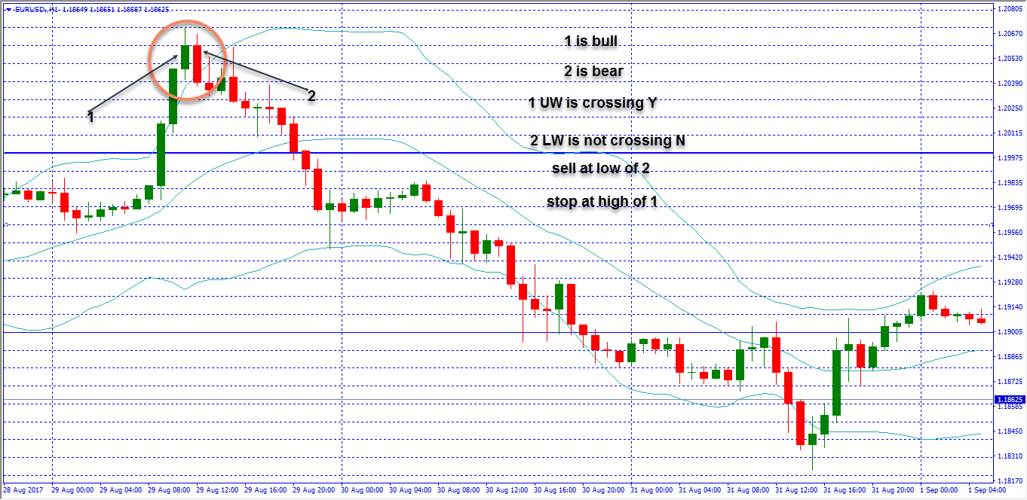

Ex: 2
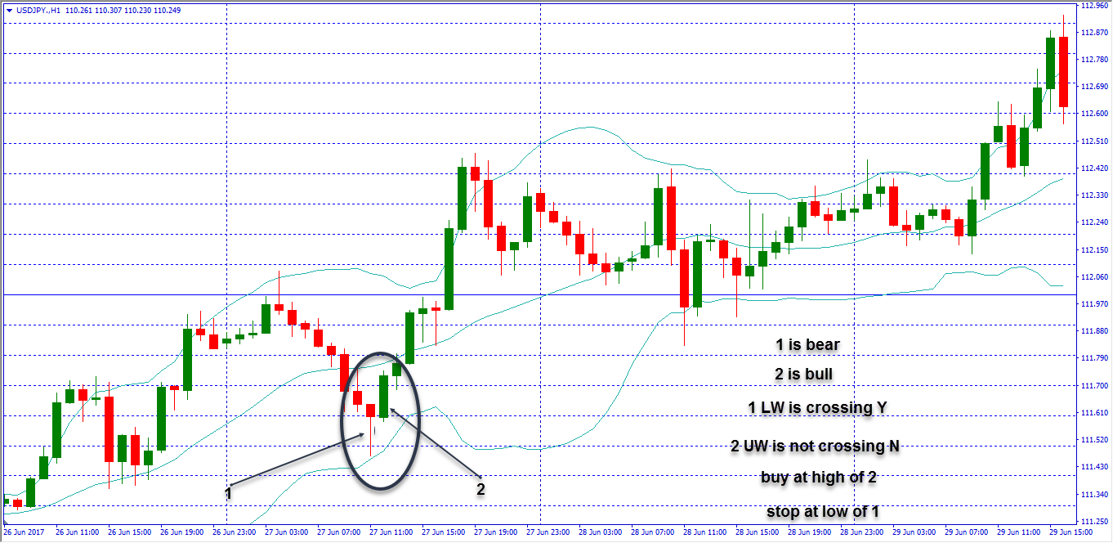

Ex: 3
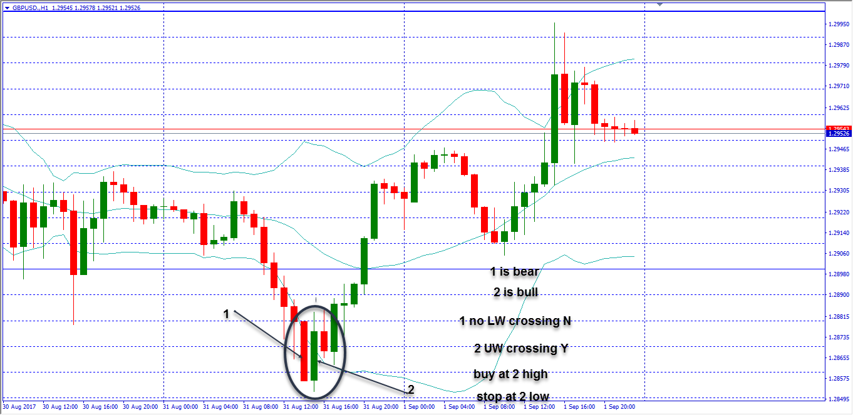
Ex: 4
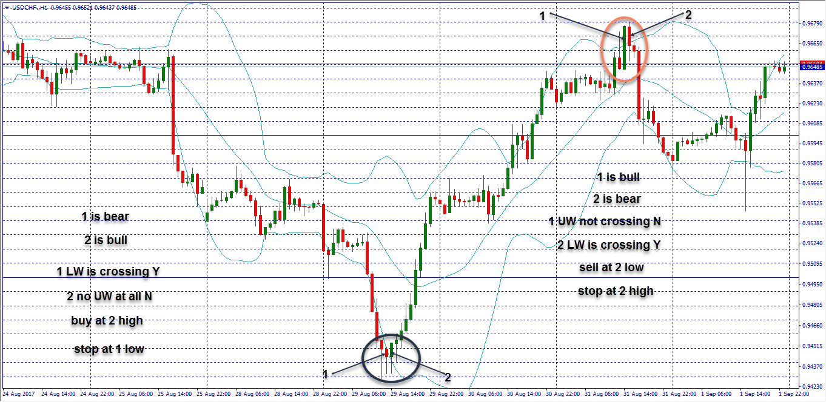
Ex: 5
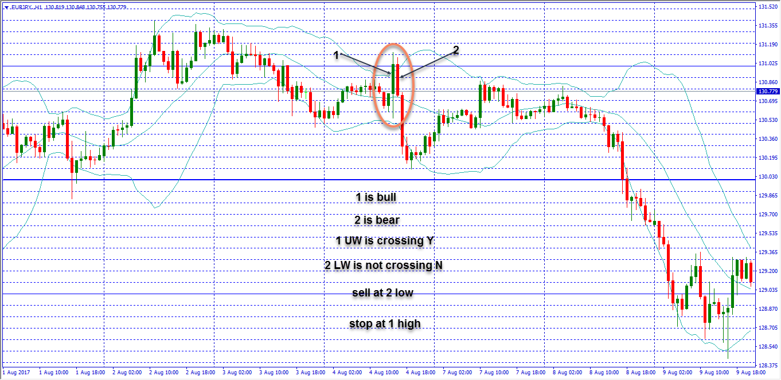
Ex: 6
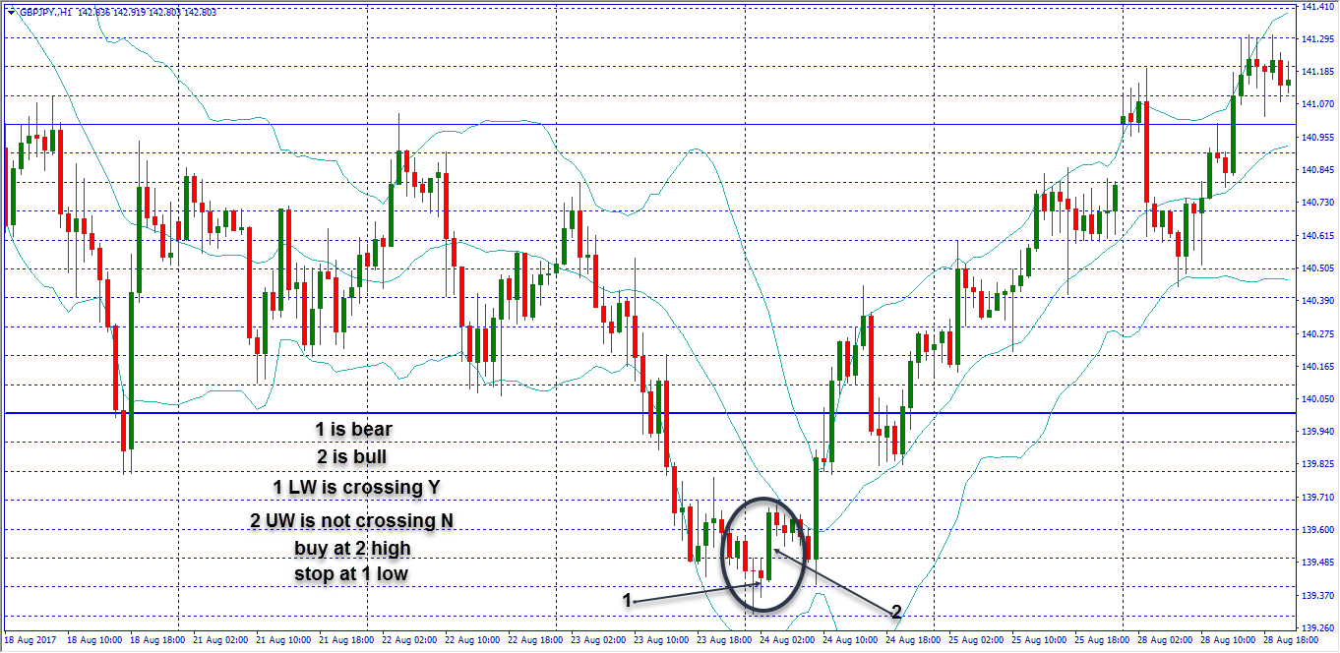
Ex: 7
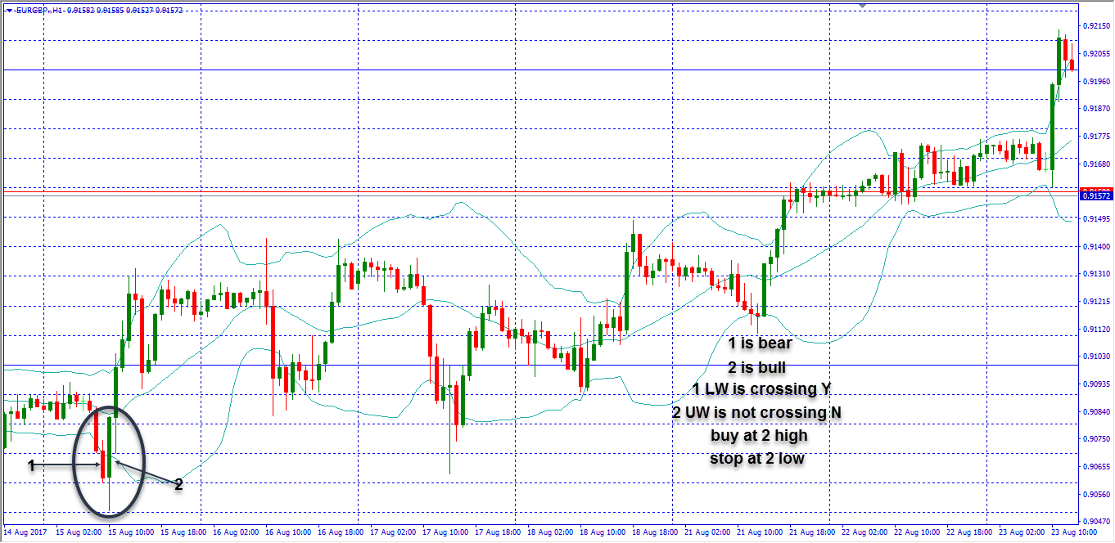
Ex: 8
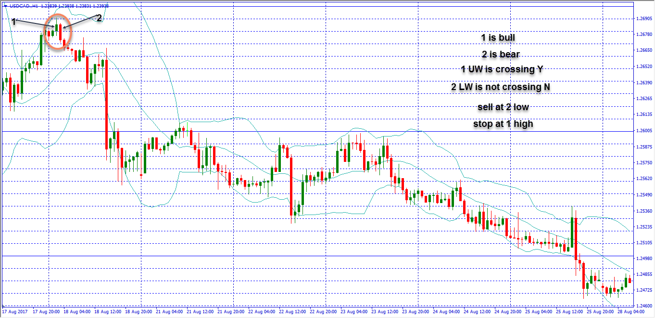
Ex: 9
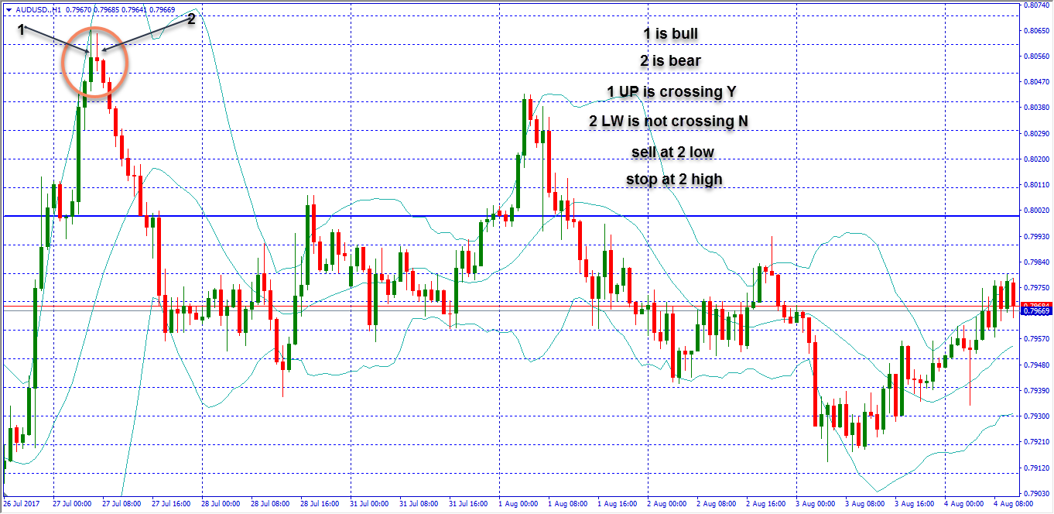
Ex: 10
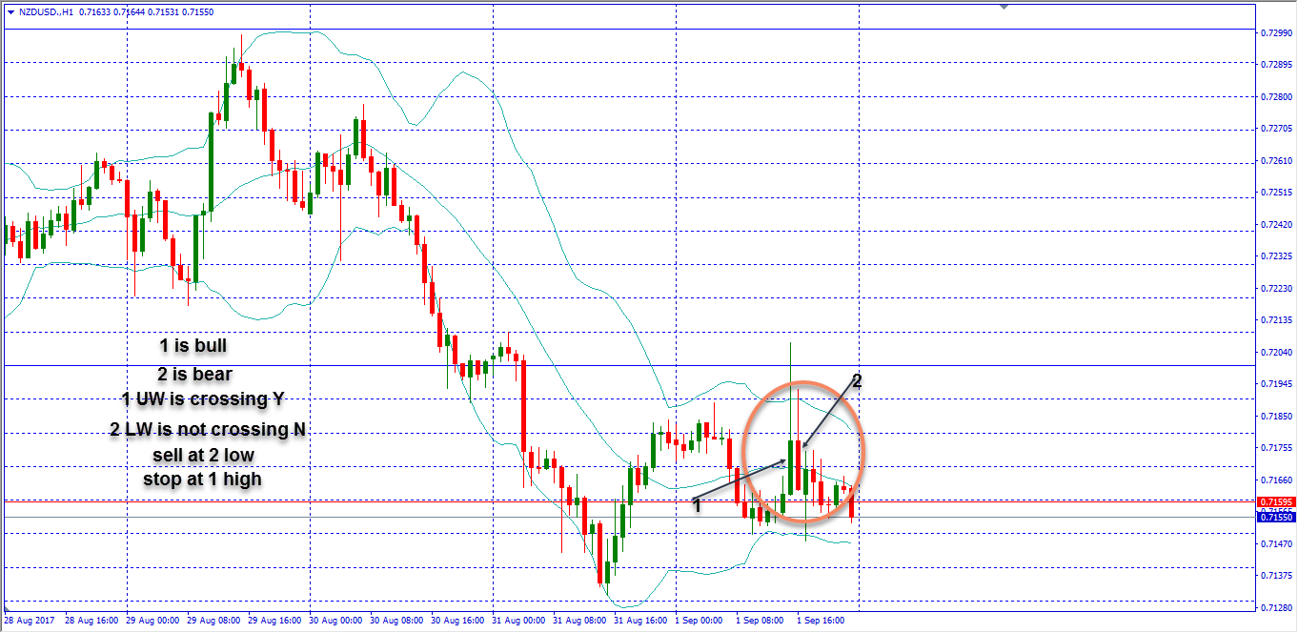

atheer1

